We have two types of web services in general. But, why should we go for RESTful web services?
To understand this, let us look at the GreetingService example that we had seen while discussing SOAP-based Web Services. This is how the SOAP request looked like.
Sample SOAP Request to GreetingService:
- Sample SOAP Request for GreetingService:
- <?xml version="1.0" encoding="UTF-8"?>
- <S:Envelope xmlns:S="http://schemas.xmlsoap.org/soap/envelope/" xmlns:SOAP-ENV="http://schemas.xmlsoap.org/soap/envelope/">
- <SOAP-ENV:Header/>
- <S:Body>
- <ns2:hello xmlns:ns2="http://infy.com/">
- <name>Rekha</name>
- </ns2:hello>
- </S:Body>
- </S:Envelope>

This XML will be embedded as "payload" inside the SOAP request envelope which in turn will be wrapped using HTTP request and then, will be sent using HTTP POST.
The SOAP Response would be:
- Sample SOAP Response for GreetingService:
- <?xml version="1.0" encoding="UTF-8"?><S:Envelope xmlns:S="http://schemas.xmlsoap.org/soap/envelope/" xmlns:SOAP-ENV="http://schemas.xmlsoap.org/soap/envelope/">
- <SOAP-ENV:Header/>
- <S:Body>
- <ns2:helloResponse xmlns:ns2="http://infy.com/">
- <return>Hello Rekha,Welcome to the world of Web Services !</return>
- </ns2:helloResponse>
- </S:Body>
- </S:Envelope>

If the same functionality is developed as a RESTful Web service, the request will be something like this,
- GET http://<server name>:<portno>/GreetingService/greetings?name=Rekha

And, the response will be like the one that follows.
- {"response":"Hello Rekha, Welcome to the world of Web Services" }

SOAP-based Web Service | RESTful Web Service
SOAP is a protocol (defines the way how messages have to be sent) which is transported over a transport layer Protocol, mostly HTTP. | REST is an architectural style.
SOAP messages can be transported using other transport layer protocols (SMTP, FTP) as well. | REST leverages HTTP Protocol.
Data (XML/JSON) wrapped in a SOAP message, comes with an additional overhead of XML processing at the client and server side as well. | REST is straight forward in handling requests and responses. Since REST supports multiple data formats other than XML, there is no overhead of wrapping the request and response data in XML. Also, REST uses the existing HTTP protocol for communication. All these factors together make REST, lightweight.
SOAP-based reads cannot be cached because SOAP messages are sent using the HTTP POST method. | REST-based reads can be cached.
A predefined formal contract is required between the consumer and the provider. | Formal contract is not mandatory. Service description can be done if needed, using a less verbose way with the help of WADL.

RESTful web services are fast, scalable and modifiable.
RESTful web service or REpresentational State Transfer (REST) adheres to a set of architectural principles which makes RESTful web services fast, scalable and modifiable. Below is the list of principles that REST adheres to.
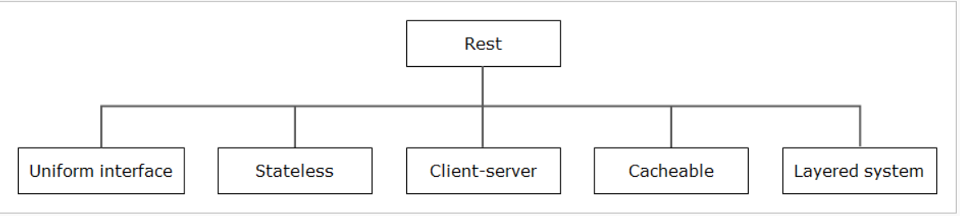
Let us understand REST principles in detail.
Uniform Interface
- In REST, data and functionality are considered as resources. Every resource has a representation (XML/JSON) and a URI to identify the same.
- Resources are manipulated using HTTP's GET, POST, PUT and DELETE methods.
We can use the HTTP Methods for the following operations on the resources.
HTTP Method | CRUD Operation | Description
GET | Read | Fetches a resource
POST | Create | Adds an existing resource to a server
PUT | Update | Transfers a resource to the server and overwrites the existing resource
DELETE | Delete | Discards resources

Example: If Customer is a resource, then Customer details can be added, deleted, updated or retrieved. If the blog is another resource, then the operations that we can perform on the blog will be read, create, update or delete.
Advantage: Single URI can perform multiple operations on the resource.
Stateless
- The interaction that takes place between the service provider and consumer is stateless.
- Being stateless, the server will never store the state information of its clients. Rather, every request from a service consumer should carry all the necessary information to make the server understand and process the request.
Advantage: Statelessness ensures that the requests from a consumer should get treated independently. This helps to scale the APIs (making them available in multiple servers) to support a large number of clients concurrently. Any server is free to serve any client since there is no session related dependency. Also, REST APIs stay less complex as server-side state synchronization logic is removed. On top, the performance of APIs is improvised because of less space occupation (no space is required for state-related info).
Client-Server
- Enforces the separation of concerns that helps to establish a distributed architecture. And, this is the most foundational constraint. Because of this distributed architecture with separation of concerns, the change in one component will not affect other components. In simple words, the components stay loosely coupled making them more manageable.
Advantage: Supports the independent evolution of the client and server-side logic.
Cacheable
- Service consumers can cache the response data and reuse the same. For example, HTTP GET and HEAD operations are cacheable.
- RESTful Web Services use the HTTP protocol as a carrier for the data. And, they can make use of the metadata that is available in the HTTP headers to enable caching. For example, Cache-Control headers are used to optimize caching to enhance performance.
Advantage: Enhances performance
Layered System
- REST based solution comprises of multiple architectural layers.
- The Consumer may interact directly with the actual provider or through the service that is residing in the middleware layer.
Advantage: Information hiding with a layered architecture helps to simplify the design of distributed architecture. Also, individual layers can be deployed and evolved independently.
Code-On-Demand
- This is an optional constraint which is primarily intended to allow client-side logic to be modified without doing changes in the server-side logic.
- For example, a service can be designed in such a way that it dynamically pushes part of the logic to the consumers.
Advantage: Logic that is present in the client end (such as Web browsers) can be modified/maintained independently without affecting the logic at the server side.
Spring Web MVC is the source of Spring REST as well. So, let us just quickly understand the internals of Spring MVC in detail.
Spring MVC framework is based on MVC and the front controller design patterns.
The core element of Spring MVC is the Dispatcher Servlet and, that is the Front Controller which provides an entry point for handling all the requests and forwards the same to the appropriate components.
The Dispatcher Servlet interacts with handler mappings to determine which controller to execute upon user request. Same way, it consults view resolver to decide the view in which the response to be rendered.
Spring provides support for creating RESTful web services using Spring MVC. Availing this support requires, Spring version 3.0 and above.
The REST controllers are different from MVC controllers because REST controllers' methods return results which can be mapped to a representation rather than a view.
For this, Spring 3.0 introduced @ResponseBody annotation. So, the methods of REST controllers that are annotated with @ResponseBody tells the DispatcherServlet that the result of execution need not to be mapped with a view.
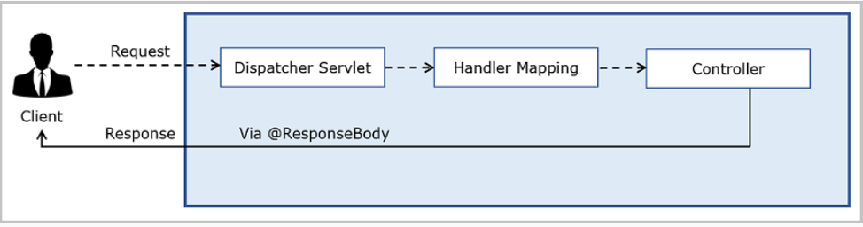
@ResponseBody annotation automatically converts the response to a JSON string literal by applying serialization on the return value of the method.
Spring MVC | Spring REST
Spring MVC response is a View/Page by default | In Spring REST data is returned directly back to the client

- Application class is simply annotated with @SpringBootApplication
- @SpringBootApplication
- public class InfytelDemo1Application {
- public static void main(String[] args) {
- SpringApplication.run(InfytelDemo1Application.class, args);
- }

- }

@SpringBootApplication is a convenient annotation that adds the following:
- @Configuration marks the class as a source where bean definitions can be found for the application context.
- @EnableAutoConfiguration tells Spring Boot to start adding beans based on the classpath and property settings.
- @ComponentScan tells Spring to look for other components, configurations, and, services in the packages being specified.
And, one more point to be added here is,
@EnableWebMvc is used explicitly in a regular Spring MVC application. But, Spring Boot adds it automatically when it sees spring-webmvc on the classpath. This marks the application as a web application and enables the key behaviors such as setting up the DispatcherServlet etc.
Whenever Spring encounters @RequestBody, it takes the help of the registered HttpMessageConverters which will help convert the HTTP request body to Java Object depending on the MIME type of the Request body.
Example: The above code is equivalent to the below code that promotes the application of the attribute, consumes.
- @PostMapping(consumes="application/json")
- public ResponseEntity<String> createCustomer( @RequestBody CustomerDTO customerDTO)
- {
- // logic goes here
- }
consumes attribute can be supplied with a single value or an array of media types as shown below
- consumes = "text/plain"
- or
- consumes = {"text/plain", "application/json"}

- Some more valid values:
- consumes = "application/json"
- consumes = {"application/xml", "application/json"}
- consumes = {"text/plain", "application/*"}

Scenario-2
We can specify the MIME type, to which the data to be serialized, using the produces attribute of HTTP method matching annotations
- @GetMapping(produces="application/json")
- public List<CustomerDTO> fetchCustomer()
- {
- //This method will return the customers of Infytel
- return customerService.fetchCustomer();
- }
Just like consumes, the attribute, produces can also take a single value or an array of MIME types
- Valid values for produces attribute:
- produces = "text/plain"
- produces = {"text/plain", "application/json"}
- produces = {"application/xml", "application/json"}

As shown in the code snippet, we can use the static functions of ResponseEntity class that are available for standard Http codes (ok() method is used, here). One more way of setting response entity is as follows.
- ResponseEntity(T body, MultiValueMap<String,String> headers, HttpStatus status)
Example:
- @PostMapping(consumes="application/json")
- public ResponseEntity<String> createCustomer(@RequestBody CustomerDTO customerDTO)
- {
- HttpHeaders responseHeaders = new HttpHeaders();
- responseHeaders.set("MyResponseHeaders", "Value1");
- String response = customerService.createCustomer(customerDTO);
- return new ResponseEntity<String>(response, responseHeaders, HttpStatus.CREATED);
- }

Before we look into the ways to extract the URI data, we will have a look at the formal categorization of the data that appear in the request URI.
- Query Parameter
- Path Variables
- Matrix Variables
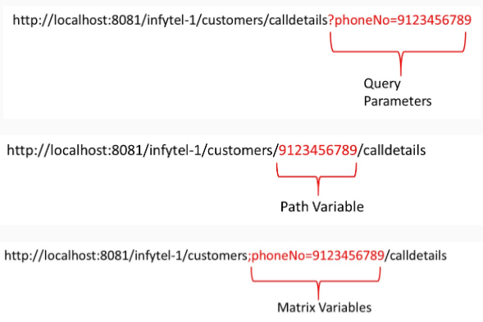
Example: Assume, there is a RestController called CallDetailsController that has a service method to return the call details of a specific phone number on a particular date. The service method here, takes the phoneNo of the customer and the date as query /request parameters.
Example URI:
- URI:http://<<hostname>>:<<port>>/<<contextpath>>/calldetails?calledBy=9123456789&calledOn=12/5/2019
- @RestController
- @RequestMapping("/calldetails")
- public class CallDetailsController
- {
- //Fetching call details based on the request parameters being passed along with the URI
- @GetMapping(produces = "application/json")
- public List<CallDetailsDTO> callDetails(
- @RequestParam("calledBy") long calledBy, @RequestParam("calledOn") String calledOn)
- {
- //code goes here
- }
- }

We have to make sure that the name of the local parameter (int id) and the placeholder ({id}) are same. Name of the PathVariable annotation's argument (@PathVarible("id")) and the placeholder ({id}) should be equal, otherwise.
- @GetMapping("/{id}")
- public String controllerMethod(@PathVariable int id){}
OR
- @GetMapping("/{id}")
- public String controllerMethod(@PathVariable("id") int empId){}
- Matrix variables follow name=value format and use semicolon to get delimited from one other matrix variable.
Code:
- @RestController
- @RequestMapping("/plans")
- public class PlanController
- {

- //{query} here is a place holder for the matrix variables that travel in the URI,
- //it is not mandatory that the client URI should hold a string literal called query
- URI:http://<<hostname>>:<<port>>/<<contextpath>>/plans/localRate=1,4 /plan
- @GetMapping(value = "/{query}/plan", produces = {"application/json","application/xml"})
- public EntityList<PlanDTO> plansLocalRate(
- @MatrixVariable(pathVar="query") Map<String, List<Integer>> map ) {
- //code goes here
- }
- }
@MatrixVariable(pathVar="query") Map<String, List<Integer>> map :The code snippet mentions that all the matrix variables that appear in the path segment of name query should be stored in a Map instance called map. Here, the map's key is nothing but the name of the matrix variable and that is nothing but localRate. And, the value of the map is a collection of localRates (1,4) of type Integer.
Note:If the matrix variable appears towards the end of the URI as in the below example,
- URI:http://localhost:8081/infytel-1/customers/calldetails/phoneNo=9123456789
we can use the following approach to read the matrix variable.
- @GetMapping("/customers/{query}")
- public ResponseEntity<CallDetails> getCallDetails(@MatrixVariable String phoneNo)
- {
- //code goes here
- }
URI versioning involves different URI for every newer version of the API.
Example: There is a need for two versions of functionality that fetches the plan details of Infytel telecom application. And, this fetch operation is based on the planId being passed as a path variable.
version-1: Fetches the complete plan details that include plainId, planName, localRate and nationalRate
version-2: Fetches only the localRate and nationalRate.
Below is the URI proposed to be used
- GET http://localhost:8080/infytel/plans/v1/{planId}
- eg:http://localhost:8080/infytel/plans/v1/1

- GET http://localhost:8080/infytel/plans/v2/{planId}
- eg:http://localhost:8080/infytel/plans/v2/1
Now, let us look at how the handler method can be written.
For Version-1
- @GetMapping(value = "v1/{planId}")

- public ResponseEntity<PlanDTO> getPlan(@PathVariable("planId")String planId)
- {
- //Return the complete plan details
- }

For Version-2
- @GetMapping(value = "v2/{planId}")

- public ResponseEntity<PlanDTO> getPlanv2(@PathVariable("planId")String planId)
- {
- //Returns only the localRate and nationalRate
- }

Observe, how a functionality with two different versions or approaches is made available in a REST resource. Also, focus on how the consumers call the different versions of the API method using the URIs that carry information about versioning.
This type of versioning requires the inclusion of custom headers in the request URI to map to the correct version of the API endpoint.
Let us take the service that fetches plan details, here as well.
Below is the URI proposed to be used
- GET http://localhost:8080/infytel/plans/{planId}
- headers=[X-API-VERSION=1]

- eg:http://localhost:8080/infytel/plans/1 and pass the header information headers=[X-API-VERSION=1]

- GET http://localhost:8080/infytel/plans/{planId}
- headers=[X-API-VERSION=2]

- eg:http://localhost:8080/infytel/plans/1 and pass the header information headers=[X-API-VERSION=2]
Now, let us look at how the handler method can be written
For Version-1
- @GetMapping(value = "{planId}",headers = "X-API-VERSION=1")

- public ResponseEntity<PlanDTO> getPlan(@PathVariable("planId")String planId)
- {
- //Return the complete plan details
- }

For Version-2
- @GetMapping(value = "{planId}",headers = "X-API-VERSION=2")

- public ResponseEntity<PlanDTO> getPlanv2(@PathVariable("planId")String planId)
- {
- //Returns only the localRate and nationalRate
- }
Accept Header Versioning approach is one other way of versioning the API methods that insists the usage of Accept Header in the request.
- GET http://localhost:8080/infytel/plans/{planId}
- headers=[Accept=application/vnd.plans.app-v1+json]

- eg:http://localhost:8080/infytel/plans/1 and pass the header information headers=[Accept=application/vnd.plans.app-v1+json]

- GET http://localhost:8080/infytel/plans/{planId}
- headers=[Accept=application/vnd.plans.app-v2+json]

- eg:http://localhost:8080/infytel/plans/1 and pass the header information headers=[Accept=application/vnd.plans.app-v2+json]
Now, let us look at how the handler method can be written
For Version-1
- @GetMapping(value = "/{planId}", produces = "application/vnd.plans.app-v1+json")

- public ResponseEntity<PlanDTO> getPlan(@PathVariable("planId")String planId)
- {
- //Return the complete plan details
- }

For Version-2
- @GetMapping(value = "/{planId}", produces = "application/vnd.plans.app-v2+json")

- public ResponseEntity<PlanDTO> getPlanv2(@PathVariable("planId")String planId)
- {
- //Returns only the localRate and nationalRate
- }
Request parameter versioning can be achieved by providing the request parameter in the URI that holds the version details.
- GET http://localhost:8080/infytel/plans/{planId}?version=
- eg:http://localhost:8080/infytel/plans/1?version=1

- GET http://localhost:8080/infytel/plans/{planId}?version=
- eg:http://localhost:8080/infytel/plans/1?version=2
Now, let us look at how the handler method can be written
For Version-1
- @GetMapping(value = "/{planId}", params = "version=1")

- public ResponseEntity<PlanDTO> getPlan(@PathVariable("planId")String planId)
- {
- //Return the complete plan details
- }

For Version-2
- @GetMapping(value = "/{planId}", params = "version=2")

- public ResponseEntity<PlanDTO> getPlanv2(@PathVariable("planId")String planId)
- {
- //Returns only the localRate and nationalRate
- }
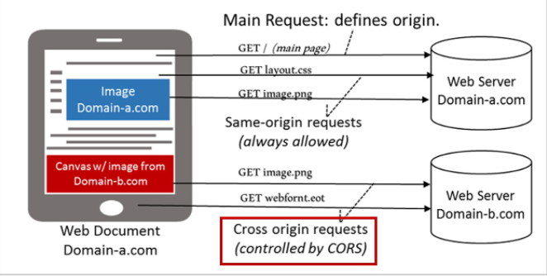
Cross-origin calls can be enabled for Spring REST resources in three ways by applying:
- CORS configuration on the REST controller methods
- CORS configuration on the REST controller itself
- CORS configuration globally (common to the entire application)
CORS configuration on controller methods:
In this style, we need to apply @CrossOrigin on the handler method.
Here, the annotation, @CrossOrigin enables cross-origin requests only for the specific handler method.
By default, it allows all origins, all headers, all HTTP methods specified in the @RequestMapping annotation. Also, a lot more other defaults are available.
We can customize this behavior by specifying the value for the following attributes that are available with Http method mapping annotations (@GetMapping, @PostMapping, etc.,)
- origins - list of allowed origins to access the method
- methods - list of supported HTTP request methods
- allowedHeaders - list of request headers which can be used during the request
- exposedHeaders - list of response headers which the browser can allow the clients to access
- allowCredentials - determines whether the browser can include cookies that are associated with the request
Example:

- @Controller
- @RequestMapping(path="/customers")
- public class CustomerController
- {
- @CrossOrigin(origins = "*", allowedHeaders = "*")
- @GetMapping()
- public String homeInit(Model model) {
- return "home";
- }
- }

CORS configuration on the controller:
It is possible to add @CrossOrigin at the controller level as well, to enable CORS for all the handler methods of that particular controller.
- @Controller
- @CrossOrigin(origins = "*", allowedHeaders = "*")
- @RequestMapping(path="/customers")
- public class CustomerController
- {
- @GetMapping()
- public String homeInit(Model model) {
- return "home";
- }
- }
Global CORS configuration:
As an alternative to fine-grained, annotation-based configuration, we can also go for global CORS configuration as well.
Look at the code below. The starter class has been modified to implement WebMvcConfigurer and override addCorsMappings() method that takes the CorsRegistry object as argument using which we can configure the allowed set of domains and HTTP methods as well.
- @SpringBootApplication
- public class InfytelApplication implements WebMvcConfigurer {

- public static void main(String[] args) {
- SpringApplication.run(InfytelDemo8BApplication.class, args);
- }

- @Override
- public void addCorsMappings(CorsRegistry registry) {
- registry.addMapping("/**").allowedMethods("GET", "POST");
- }

- }

In our demo, we will enable CORS at the global level.

